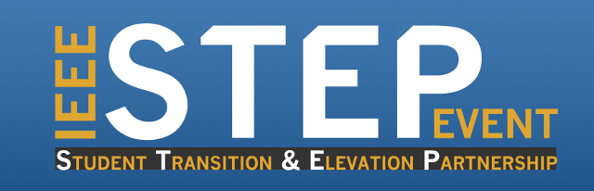
Tuesday, Oct. 14th from 6:00 pm to 8:00 pm
SEB room 2100
All ECE students are welcome to attend
Free Pizza & Soft Drinks

The event will give students the opportunity to listen to and have a Q/A with experienced panelists from the industry.

Topics include but not limited to:
1- What are the best methods to approach the job market after graduation?
2- What can make your way to an academic position faster?
3- What are the main attributes that can get you through the door?
4- What facilities does the university/department provide to assist you when you are starting your professional career?
And any question YOU might have about starting your career!!
Please RSVP at: http://goo.gl/PdT36r or https://www.surveymonkey.com/s/BG6NVBL

